**CSI3670**

**Winter 2019**

**Lab 6: IIS/MSSQL**

**Due date: March 28th @ 11:59pm**

**Synopsis**

Let’s create a wiki. *Fanfare*

**Installation**

First things first, we need to install IIS and SQL Server. IIS is an easy install.

* Open up your Server Manager → Manage → Add Roles → Web Server (IIS).

Recall that if you want to run an FTP server as well, you’ll need to check FTP Server (This is on the Role Services page .. a few ‘Next >’ clicks past selecting IIS.

Once that is installed, open up a browser (in your VM) and navigate to [http://localhost](http://localhost/). **Take a screenshot of the default web site and paste it in Q1.**

Next we’ll install SQL Server Express edition. I’m going with Express because I’m not 100% that everybody can access the full version up on Microsoft Imagine. If you can, feel free to pull down the full version, but these instructions will focus on Express.

In your VM, go to this link: <https://go.microsoft.com/fwlink/?LinkID=799012>

Save the file it asks you to download and run it when done. Alternatively, you can search for SQL Server Express (we’re installing the 2016 edition). Note you'll need to enable File Downloads if you haven't … there are steps in prior labs for this!

Select **Basic** and off we go.

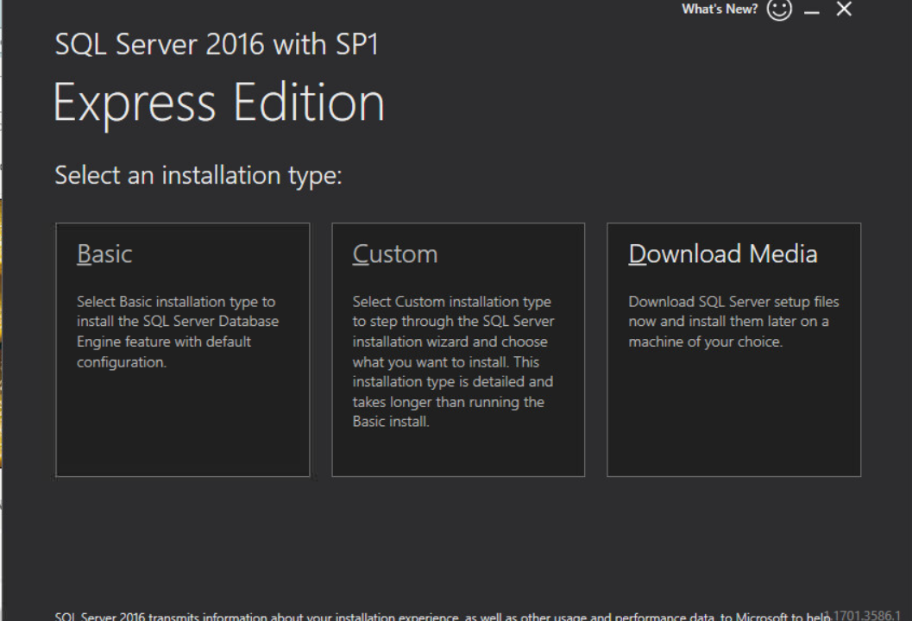

Click the Install SSMS button to download the management studio. Download SQL Server Management Studio (16.5.3) on the webpage that pops up and install.

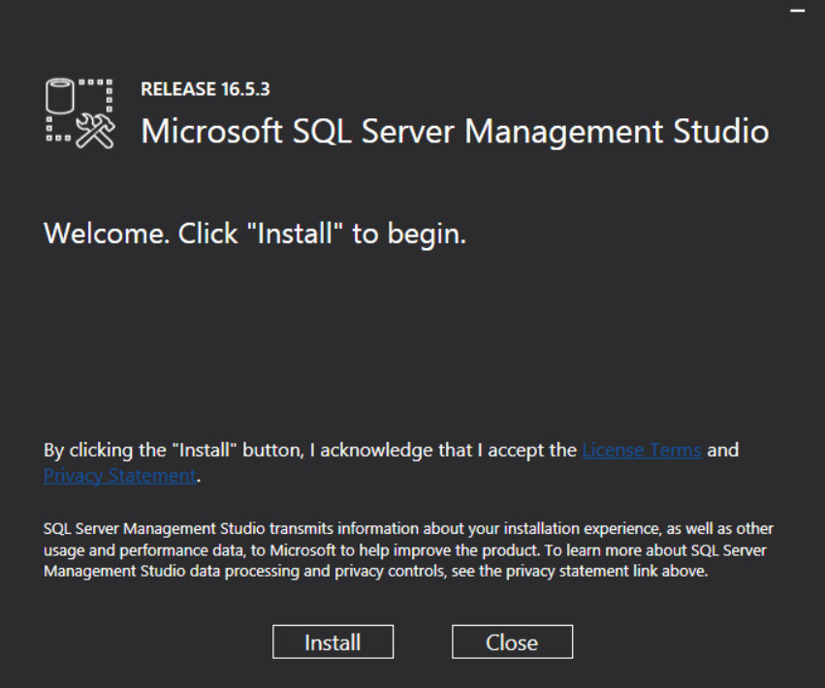

Open up the SQL Server Management Studio and connect to the default database. We need to set a default password for the sa account.

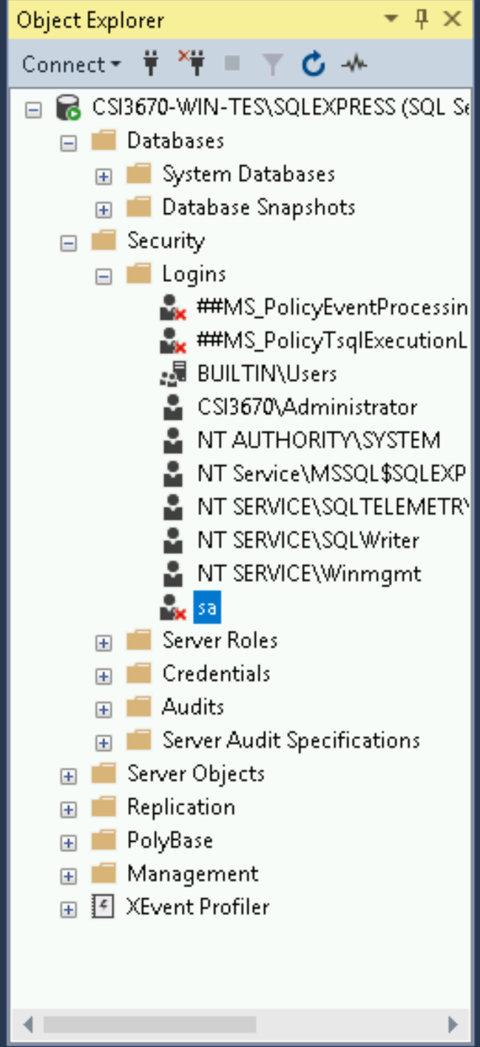

Right click on it and select Properties. Change the password to Temp12345. Deselect 'Enforce Password Policy.' Under Status click 'Enabled' otherwise it won't be allowed to login.

Right click on the server at the top (mine starts with CSI3670-WIN-TES…) and click Properties. Click Security. Set it to Mixed Mode (**SQL Server and Windows Authentication mode**). Right click again and restart the server.

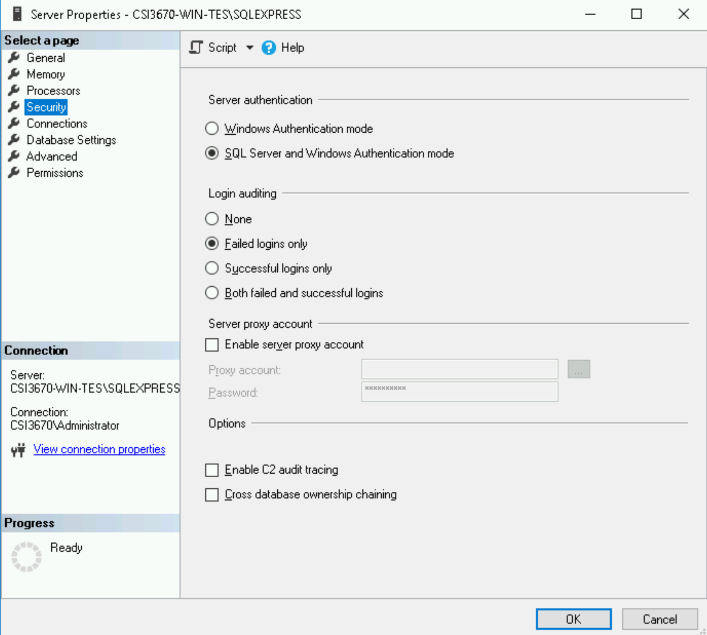

Download the Web Platform Installer here by clicking 'Install this Extension': <https://www.microsoft.com/web/downloads/platform.aspx>

From the Start menu, open the Web Platform Installer. Click the Applications tab, click Forum, then install **Yet Another Forum**. You can also do this in IIS -> Web Platform Installer.

When the installer prompts you, leave it at Default Site. Give it an application name of **YAF**.

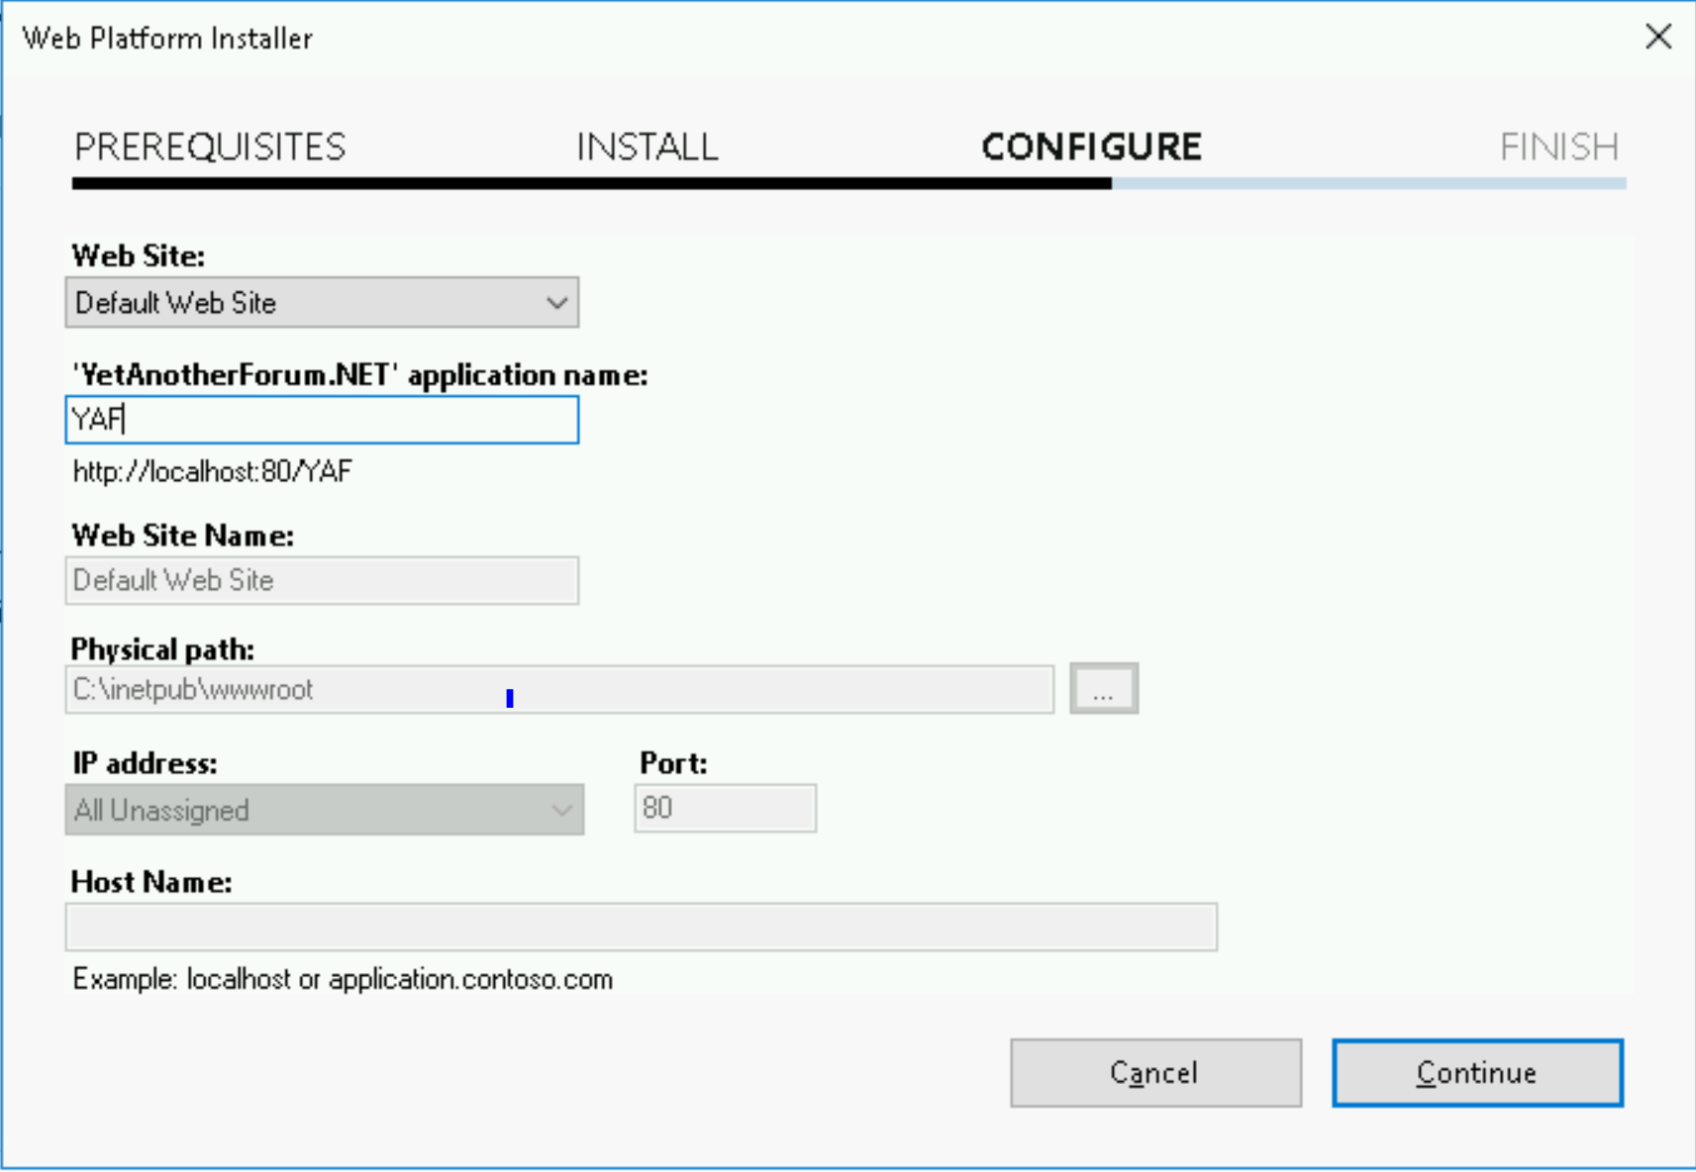

Now, browse to [http://localhost](http://localhost/)/YAF and let’s try to configure it.

Uh oh, you’ll probably see an ugly error message.

Go to IIS and Application Pools. Right click on YAF 🡪 Basic Settings 🡪 Change its .NET CLR version to 4.0.

Still an error if you restart your site.

Then, go to the Add Role page, expand Web Server, and add everything related to ASP.NET 4.6.

Restart again and it should take you to the config page.

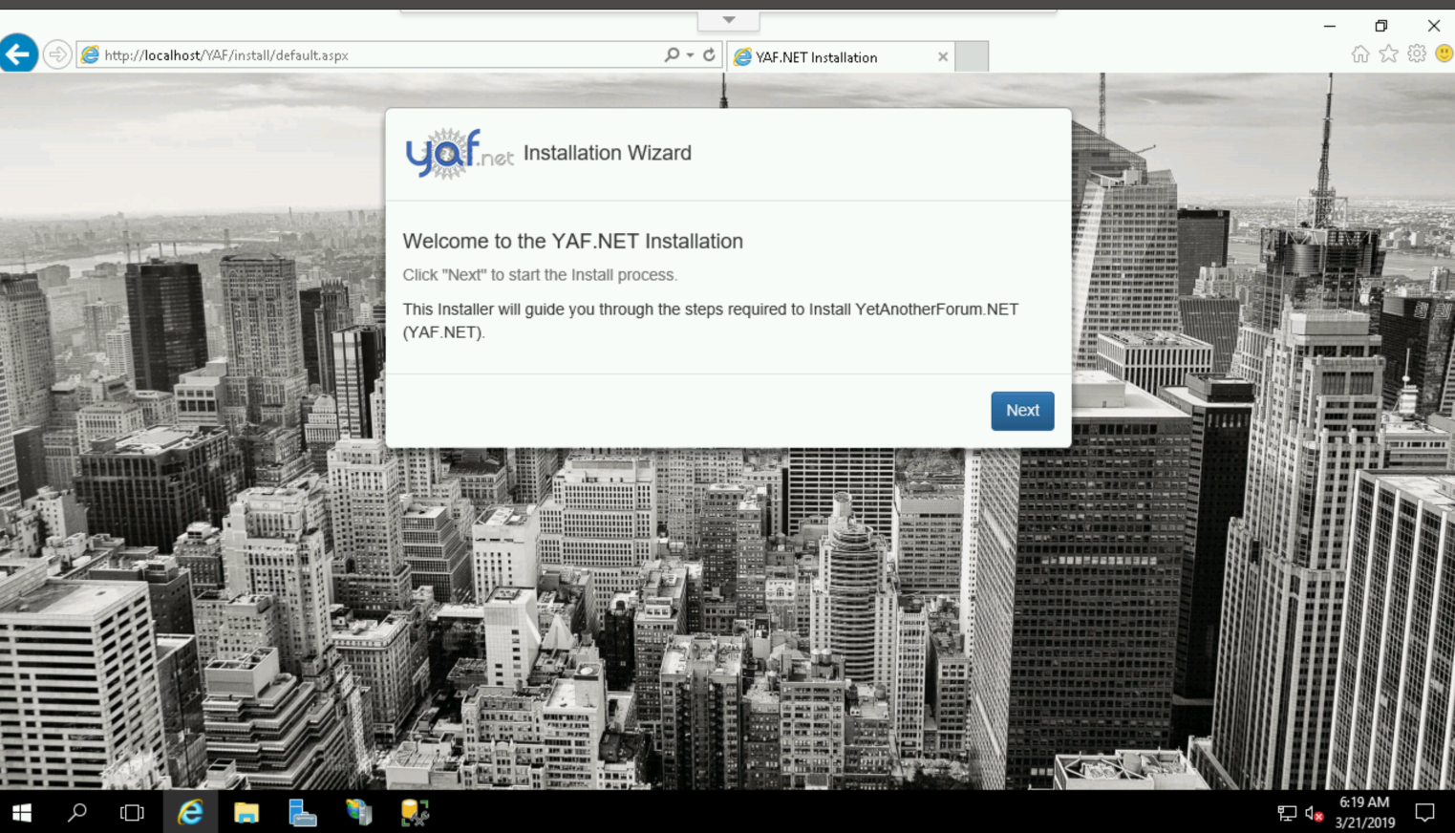

Walk through the configuration, skipping the email settings. Add /YAF to the Base Url Mask.



If you get 'The operation timed out' then just refresh. It *should* take care of it.

**Take a screenshot of the YAF homepage and paste it in Q1 to show that it’s working.**

**Homework**

1. Make sure all screenshots asked for in the lab manual have been provided.

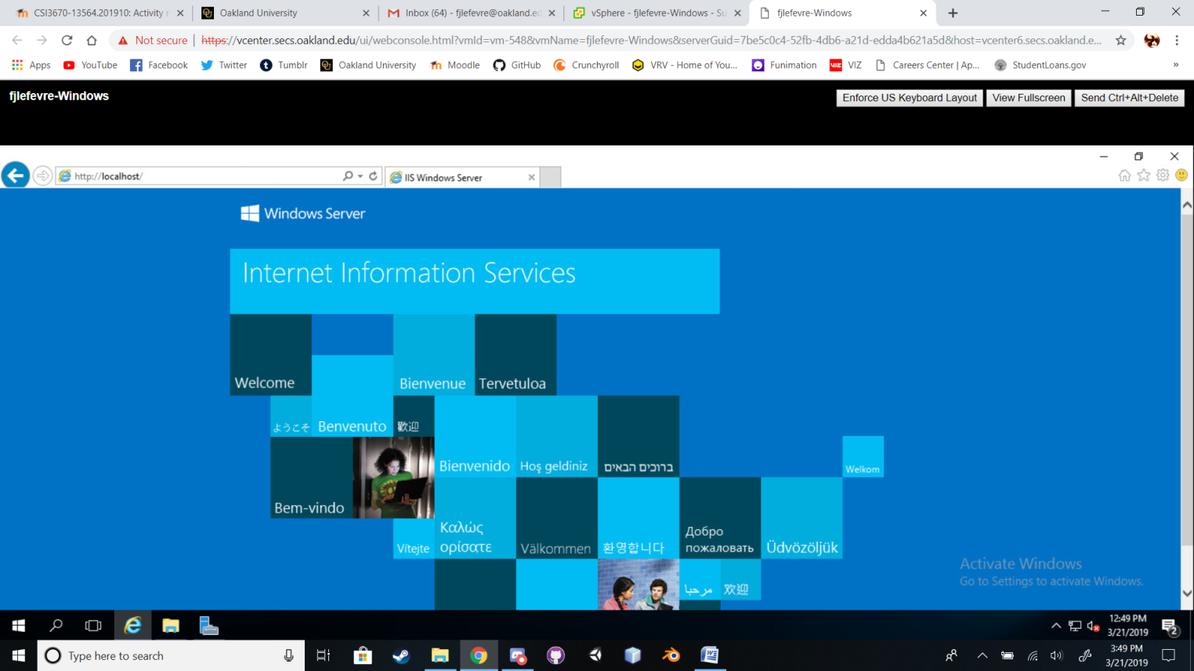

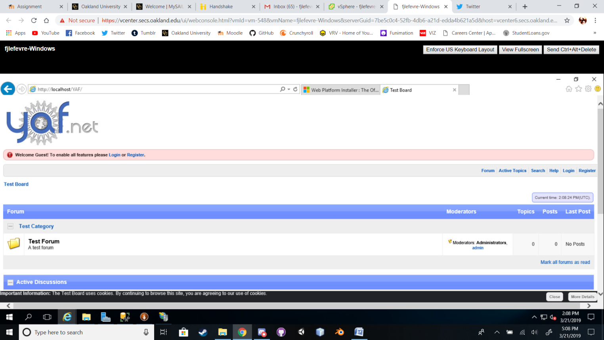

1. What are two differences (**other than cost**) between SQL Server and SQL Server Express Edition?
2. What is a default website in IIS? If you wanted to create a new default website (not using the existing default website), what steps are required to do so?
3. Describe the differences between Digest, Forms, and Windows authentication for IIS applications/sites.
4. What is an application pool?
5. Assume that you wanted IIS to run PHP pages. What would you have to do in order to serve PHP content?
6. Create some subforums for your project team and screenshot them. Make a sample post and screenshot that too.